**General Progress Report**

*Names*: Anders C, Dawson H, Mason C, Ren C, Will Z

*Game Title*: Fishing Frenzy

*Changes Since Milestone B*: In part B, our team worked on regulating the reproduction of the fish, as well as adding other fishing methods to the game in our operators. The team decided that we will use a grid-like system to formulate our game, with each fish image representing 1,000 fish of the species. We then decided the amount of fish that each fishing method would farm, and only allowed the player to use different fishing methods on species that made real-world sense.

**Discussion of Game Elements**

*Learning Curves:* The “learning curve” for our game will be small, with a larger spike of learning at the beginning for the player to figure out the game mechanics (how the options are presented, the consequences that come with each choice the player makes), but as it is a relatively simple game, the player is expected to catch on fairly quickly.

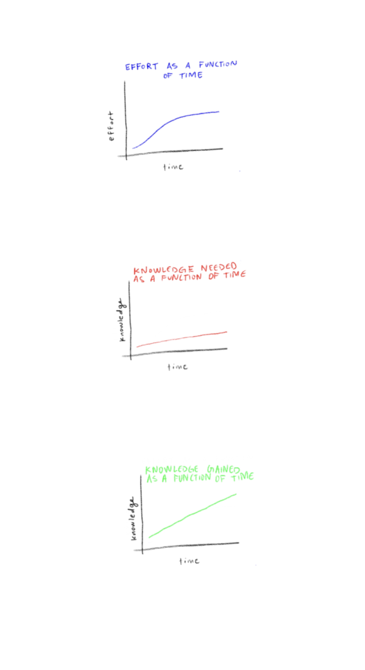

*Effort:* In general, this game will not require much effort to play as it is catered toward educational purposes. It will require slightly more effort, in the beginning, to learn about the different types of fishing and how they affect the environment and ecosystem. Thus, the graph of effort as a function of time is an “s curve” that levels out relatively quickly.

*Knowledge Needed:* The player does not need much knowledge of the concepts of this game to play. A basic understanding of how fishing works will suffice. As the game goes on, the player will be taught information on how each of the various fishing methods included affects the ecosystem and will use that knowledge to play the game better. Thus, the graph of knowledge needed as a function of time is a linear line with a slight slope (very little knowledge is needed at the start but increases slowly after learning).

*Knowledge Gained:* As the primary purpose of this game is education, the player will gain knowledge as time goes on. As mentioned above, the player playing the game will increase their knowledge of types of fishing, and the extent to which these types of fishing will destroy the ecosystem. Thus, the graph of knowledge gained as a function of time is a linear line with a larger slope (relative to the knowledge needed line), which will level out at some point (when all the information in the game has been taught to the player).

*How Knowledge Will Be Conveyed:* Little to no prior knowledge is required to play this game. As long as the player actively learns about each fish species and fishing method, they will be able to learn the various merits of each method and how they are effective in catching different types of fish. The player will also learn about how these fishing methods may harm the ecosystem (by causing loss of biodiversity via overfishing and/or bycatch). Before the game starts, the player will be able to learn about this information via information panels. For example, the fishing method of trawling (one of the options in the game) is an effective way to catch large amounts of fish and other marine organisms but has the drawback of a high bycatch rate. Bycatch is when nontarget species are caught unintentionally and usually discarded (after often being damaged/injured or killed), potentially causing an imbalance in the food chain. This part of knowledge will be emphasized during the trial-and-error exploration.

*Embedded Game Structures: (a)* No, we only set one role for the game. *(b1)* The second role we can think of is to be the boss of the fishing company. The boss should set up good business relationships with customers and manage their employees well so that they won’t apply fishing methods outside of the plan and possibly damage the ecosystem. *(c2)* The possible operators for the company’s boss: set workers to start fishing, stop workers from fishing; hire and train new workers, teach them about the fishing methods and seriousness of overfishing; tell the workers about the target species required by the customers.

*Scoring or Indicators of Progress:* The “level” indicator that this game will include is the net profit that the company makes based on the fishing method the player chooses. The profit will act as a score. Players will also monitor the state of the ocean as the game progresses. Depending on the fishing method they choose, there will be more or less fish present in the water than when the game started. The fish population in the ecosystem, as well as the process of keeping that amount of fish at a steady number, represents the actual phenomenon of biodiversity loss in relation to real-world fishing. The profit functions as a state variable, as it is added to each round. The number of fish functions as a property of the state.

**Implementation Considerations**

*State Representation:* The class State is used to represent our game states. This class includes __init__() that defines the state variables, can_move() that checks the number of fish left to see if the move is possible, fishing_method() that changes the amounts of fish differently given the method and species chosen, move() that creates a new state with updated state variables and implements the fishing method function, is_goal() that checks if a goal state is reached when roundsLeft is 0, __eq__() that checks if two states have the same state variables and their values, __str__() that prints out the current state of the game, __hash__() that returns an object’s hash value, and goal_message() that returns the goal message.

*Initial State:* The initial state of the game is displayed as the following information: CURRENT_STATE = (Profit: 0, Biodiversity Index: 0, Biodiversity Score: 100, salmon left: 5000, tuna left: 5000, cod left: 5000, pompano left: 5000, striped bass left: 5000, halibut left: 5000). The player is given the information of profit (starting at 0), biodiversity index (starting at 0), biodiversity score (starting at 100), and the population of each fish species (starting at 5000).

*Operators:* Currently, the operators in this game are phi0 “Do nothing”, phi1 - phi5 for the various fish species caught using longlines method (“Use longlines to fish Salmon”, “Use longlines to fish Tuna”, “Use longlines to fish Cod”, “Use longlines to fish Striped Bass”, “Use longlines to fish Halibut”), phi6 - phi8 for the various fish species caught using gill nets method (“Use gill nets to fish Salmon”, “Use gill nets to fish Cod”, “Use gill nets to fish Pompano”), phi9 - phi10 for the various fish species caught using purse seines method (“Use purse seines to fish Salmon”, “Use purse seines to fish Tuna”), phi11 - phi13 for the various fish species caught using trawling method (“Use trawling to fish Cod”, “Use trawling to fish Halibut”, “Use trawling to fish Cod and Halibut”), and phi14 - phi20 for the various fish species caught using rod and reel method (“Use rod and reel for two random fish species”, “Use rod and reel to fish for Salmon”, “Use rod and reel to fish for Tuna”, “Use rod and reel to fish for Cod”, “Use rod and reel to fish for Pompano”, “Use rod and reel to fish for Striped Bass”, “Use rod and reel to fish for Halibut”).

*Specification of the Current Working Code:* The code is currently functional. It compiles without errors and displays the initial game state: CURRENT_STATE = (Profit: 0k, Biodiversity Index: 0, Biodiversity Score: 100, salmon left: 6000, tuna left: 6000, cod left: 6000, pompano left: 6000, striped bass left: 6000, halibut left: 5000). The player has the ability to pick between the operators (fishing methods), each of which will change the state of the game. For example, selecting operator 11 (phi11 - “Use rod and reel to fish for Halibut) updates the state from the initial state: CURRENT_STATE = (Profit: 54600k, Biodiversity Index: 0.8, Biodiversity Score: 100, salmon left: 10000, tuna left: 10000, cod left: 0, pompano left: 10000, striped bass left: 10000, halibut left: 10000). As shown by the example, each operator selection will impact the state by changing the profit, biodiversity index, biodiversity score, and populations of one or multiple species.

*Specification for Your Upcoming "Working Prototype" Code:* As mentioned in the section discussing operators, the remaining changes include incorporating longlines, purse seines, and trawling for singular species. Furthermore, we plan on updating the profit system of the game to make it more accurate with the current fish market (hopefully more realistic). With the incorporation of these changes, Milestone D will be a high-quality and complete game. There are no bugs to be fixed or other features to be added.